Lab 8.1.4.9 Subnetting Network Topologies

1. Objectives

* Determine the number of subnets.
* Design an appropriate addressing scheme.
* Assign addresses and subnet mask pairs to device interfaces.
* Examine the use of the available network address space and future growth potential.

1. Background / Scenario

When given a network topology, it is important to be able to determine the number of subnets required. In this lab, several scenario topologies will be provided, along with a base network address and mask. You will subnet the network address and provide an IP addressing scheme that will accommodate the number of subnets displayed in the topology diagram. You must determine the number of bits to borrow, the number of hosts per subnet, and potential for growth as specified by the instructions.

1. Network Topology A

In Part 1, you have been given the **192.168.10.0/24** network address to subnet, with the following topology. Determine the number of networks needed and then design an appropriate addressing scheme.

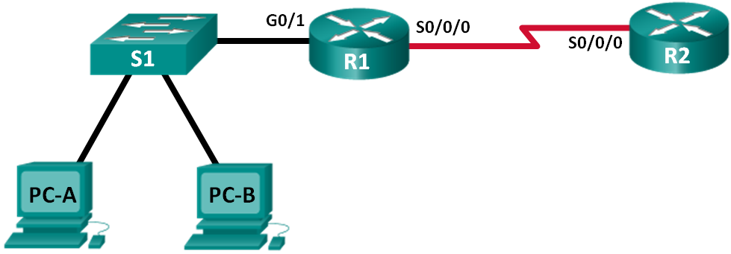

* 1. Determine the number of subnets in Network Topology A.
     1. How many subnets are there? ___________
     2. How many bits should you borrow to create the required number of subnets? _________
     3. How many usable host addresses per subnet are in this addressing scheme? ______
     4. What is the new subnet mask in dotted decimal format? _________________________
     5. How many subnets are available for future use? _______________
  2. Record the subnet information.

Fill in the following table with the subnet information:

|  |  |  |  |  |
| --- | --- | --- | --- | --- |
| Subnet # | Subnet Address | First Usable Host Address | Last Usable Host Address | Broadcast Address |
| 0 |  |  |  |  |
| 1 |  |  |  |  |
| 2 |  |  |  |  |
| 3 |  |  |  |  |

1. Network Topology B

The network topology from Part 1 has expanded to accommodate the addition of router R3 and its accompanying network, as illustrated in the following topology. Use the **192.168.10.0/24** network address to provide addresses to the network devices, and then design a new addressing scheme to support the additional network requirement.

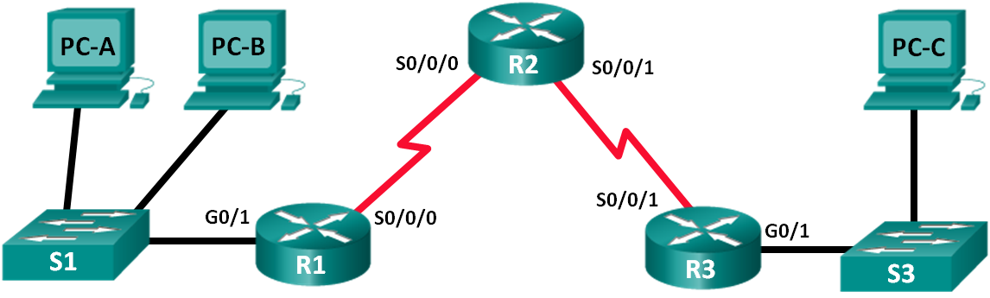

* 1. Determine the number of subnets in Network Topology B.
     1. How many subnets are there? ___________
     2. How many bits should you borrow to create the required number of subnets? _________
     3. How many usable host addresses per subnet are in this addressing scheme? _____
     4. What is the new subnet mask in dotted decimal format? _______________
     5. How many subnets are available for future use? _______________
  2. Record the subnet information.

Fill in the following table with the subnet information:

|  |  |  |  |  |
| --- | --- | --- | --- | --- |
| Subnet Number | Subnet Address | First Usable Host Address | Last Usable Host Address | Broadcast Address |
| 0 |  |  |  |  |
| 1 |  |  |  |  |
| 2 |  |  |  |  |
| 3 |  |  |  |  |
| 4 |  |  |  |  |
| 5 |  |  |  |  |